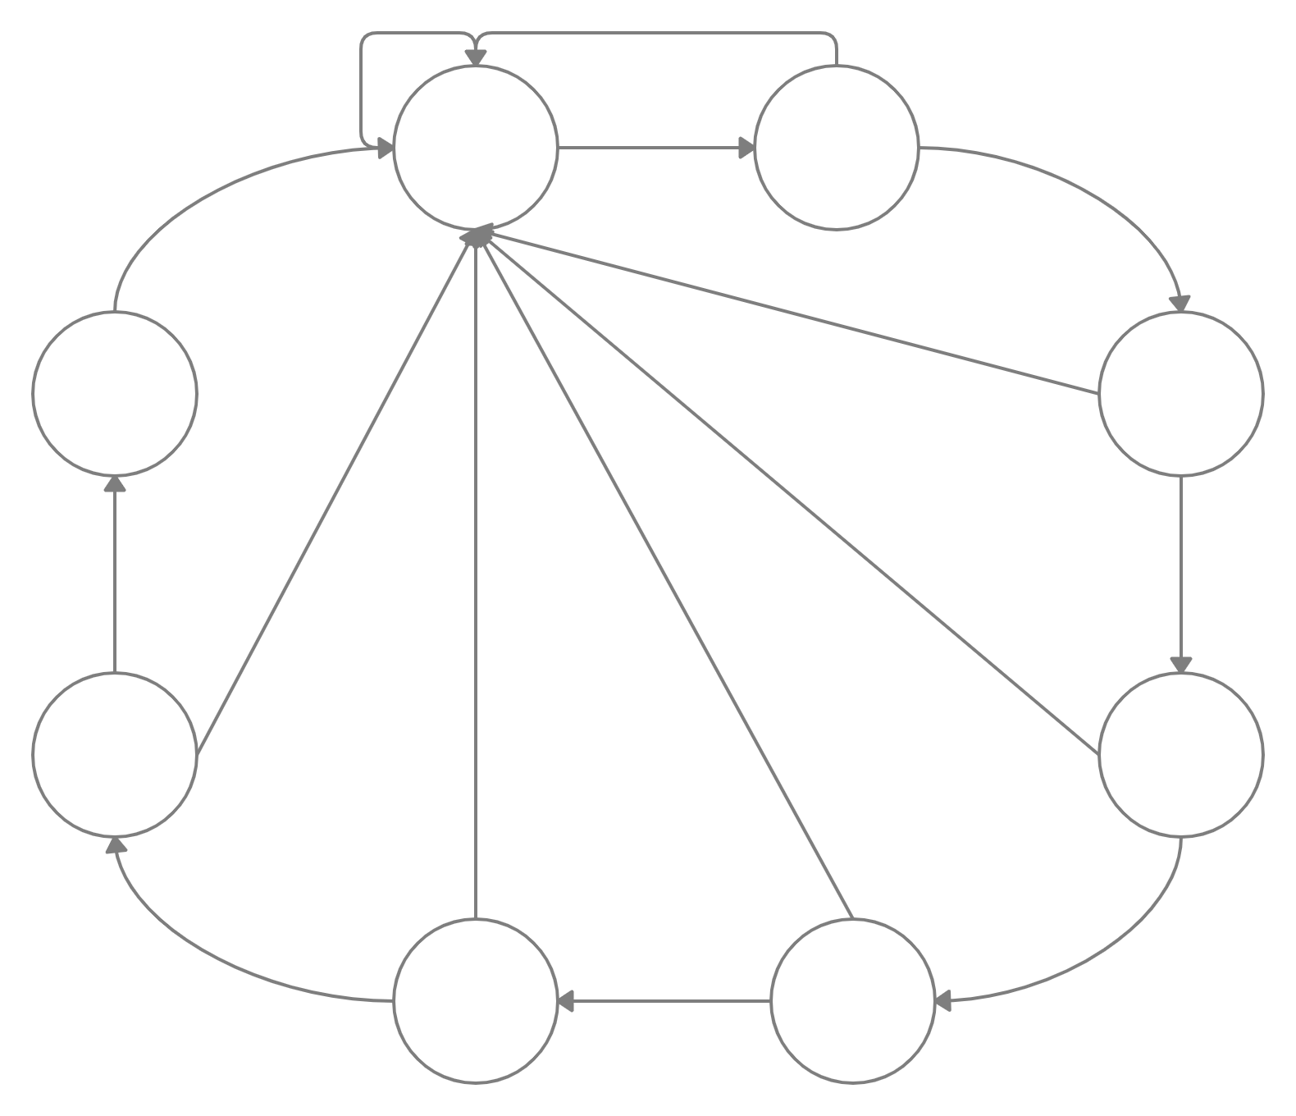

In = 000, 001, 010, 011, 100

Op = 0

In = 100, 101, 110, 111

Op = 1

In = 111

Op = 1

In = 011, 100, 101, 110, 111

Op = 1

In = 000, 001, 010, 011, 100, 101, 110

Op = 0

In = 000, 001, 010, 011, 100, 101

Op = 0

In = 000, 001, 010, 011

Op = 0

In = 000, 001, 010

Op = 0

In = 000, 001, 010, 011, 100, 101, 110, 111

Op = 0

In = 110, 111

Op = 1

In = 101, 110, 111

Op = 1

In = 010, 011, 100, 101, 110, 111

Op = 1

In = 000, 001

Op = 0

In = 001, 010, 011, 100, 101, 110, 111

Op = 1

In = 000

Op = 0

S0

S7

S6

S5

S4

S3

S2

S1